Họ tên : Lê Bảo Khánh

MSSV : 1911363

Lớp : L01

**LAB 3a**

(Using the file tcpethereal-trace-1)

**1. Capturing a bulk TCP transfer from your computer to a remote server**

**2. A first look at the captured trace**

**Question 1**: What is the IP address and TCP port number used by the client computer (source) that is transferring the file to gaia.cs.umass.edu? To answer this question, it’s probably easiest to select an HTTP message and explore the details of the TCP packet used to carry this HTTP message, using the “details of the selected packet header window” (refer to Figure 2 in the “Getting Started with Wireshark” Lab if you’re uncertain about the Wireshark windows.

**ANSWER:**

IP address of client: 192.168.1.102

TCP port number: 1161

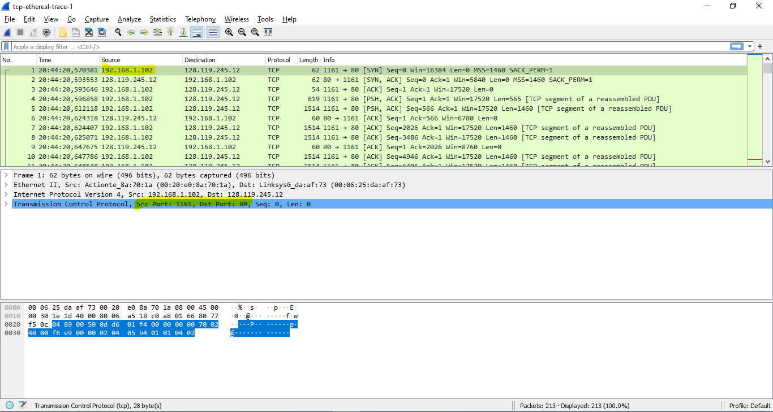

**Question 2:** What is the IP address of gaia.cs.umass.edu? On what port number is it sending and receiving TCP segments for this connection?

**ANSWER:**

* IP address of gaia server: 128.119.245.12
* Port number is it sending and receiving TCP segments: 80
* 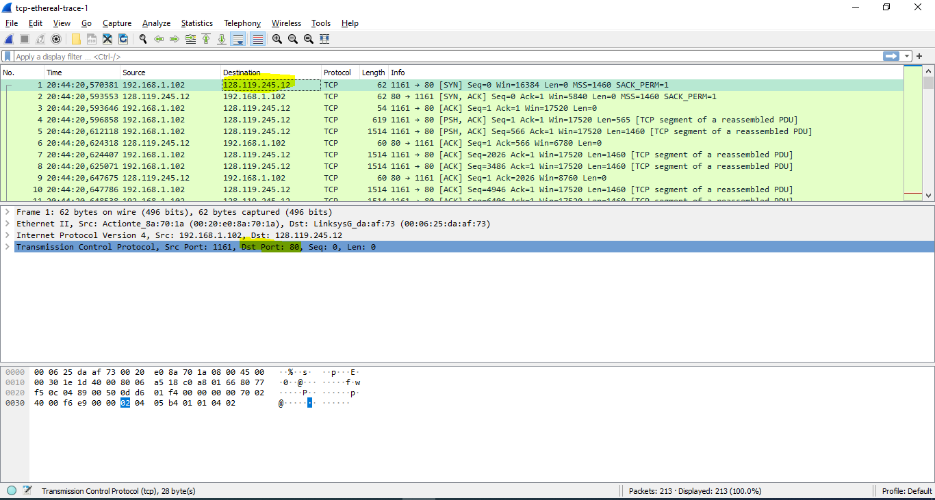

**Question 3:** What is the IP address and TCP port number used by your client computer (source) to transfer the file to gaia.cs.umass.edu?

**ANSWER:**

(use sample file)

**3. TCP Basics**

**Question 4**: What is the sequence number of the TCP SYN segment that is used to initiate the TCP connection between the client computer and gaia.cs.umass.edu? What is it in the segment that identifies the segment as a SYN segment?

**ANSWER:**

TCP SYN segment: 0

SYN Flags = 1 -> segment as SYN segment

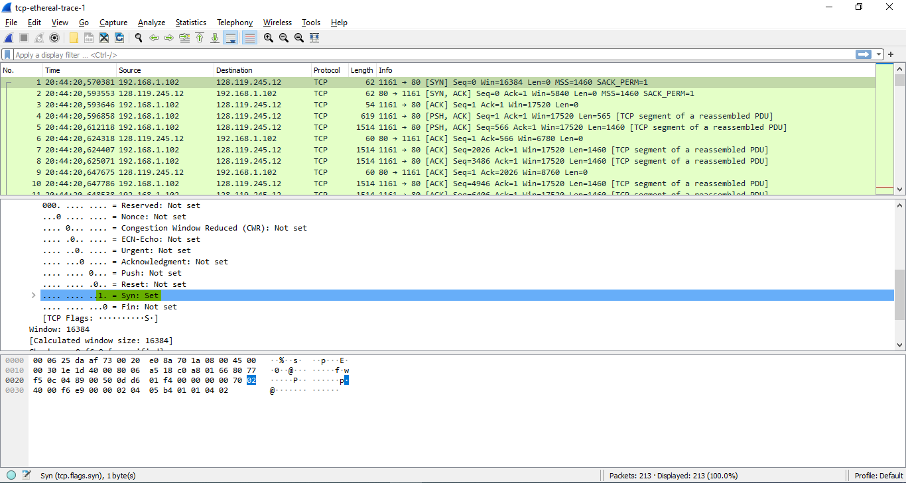

**Question 5:** What is the sequence number of the SYNACK segment sent by gaia.cs.umass.edu to the client computer in reply to the SYN? What is the value of the Acknowledgement field in the SYNACK segment? How did gaia.cs.umass.edu  
determine that value? What is it in the segment that identifies the segment as a  
SYNACK segment?

**ANSWER:**

Sequence number of the SYNACK segment: 0

SYNACK segment: SYN flag = ACK flag = 1

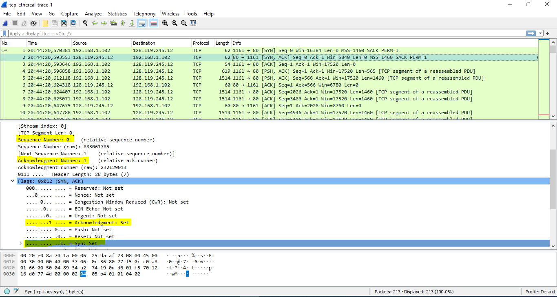

*The gaia.cs.umass.edu server adds 1 to the initial sequence number of the SYN segment from the client computer. For this case, the initial sequence number of the SYN segment from the client computer is 0, thus the value of the acknowledgement field in the SYN_ACK segment is 1. A segment will be identified as a SYN_ACK segment if both SYN flag and ACKnowledgement flag in the segment are set to 1.

**Question 6:** What is the sequence number of the TCP segment containing the HTTP POST command? Note that in order to find the POST command, you’ll need to dig into the packet content field at the bottom of the Wireshark window, looking for a segment with a “POST” within its DATA field.

**ANSWER:**

Sequence number of the TCP segment: 1

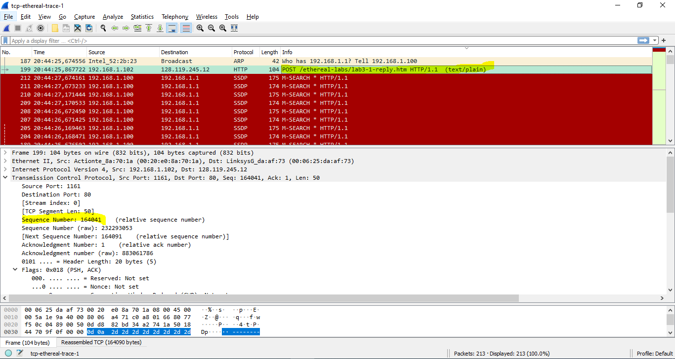

**Question 7**: Consider the TCP segment containing the HTTP POST as the first segment in the TCP connection. What are the sequence numbers of the first six segments in the TCP connection (including the segment containing the HTTP POST)? At what time was each segment sent? When was the ACK for each segment received?  
Given the difference between when each TCP segment was sent, and when its  
acknowledgement was received, what is the RTT value for each of the six  
segments? What is the EstimatedRTT value (see Section 3.5.3, page 242 in  
text) after the receipt of each ACK?

**ANSWER:**

TCP segment 1-6:

+ Packet: 4, 5, 7, 8, 10, 11

+ ACK: 9, 12, 14, 15, 16, 17

+ Sequence number: 1, 566, 2026, 3486, 4946, 6406

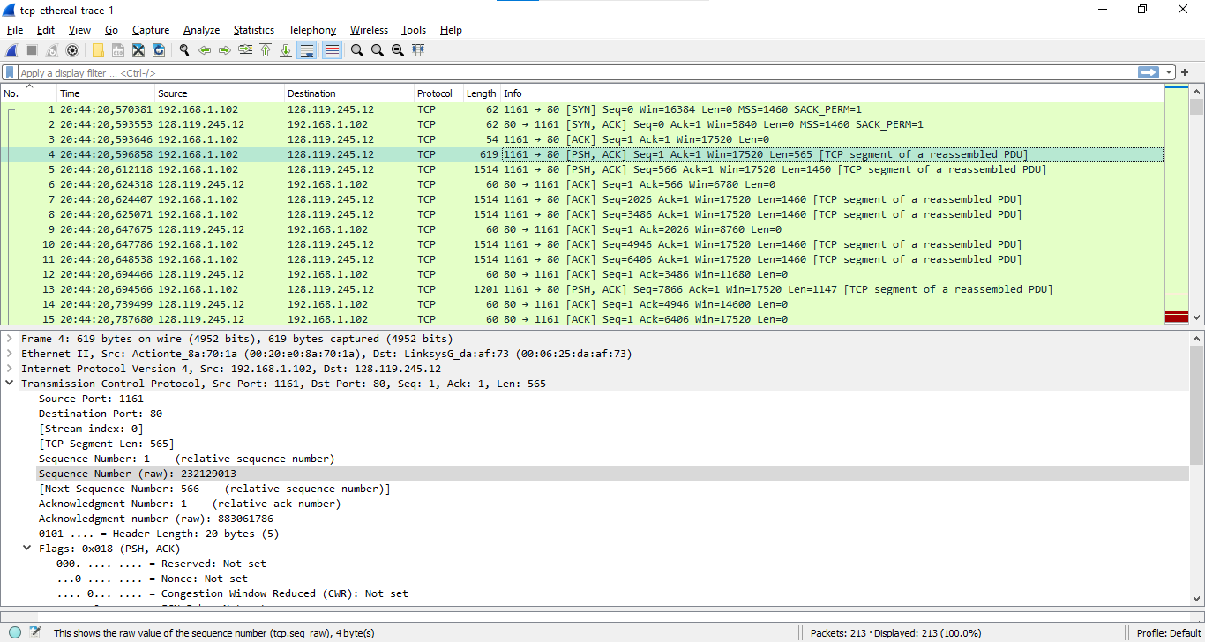

* EstimatedRTT = 0.875 * EstimatedRTT + 0.125 * SampleRTT

|  |  |  |  |  |
| --- | --- | --- | --- | --- |
| Segment | Send time | ACK received | RTT(s) | Estimated RTT after the receipt of each ACK |
| 1 | 20.596868 | 20.647675 | 0.050807 | 0.050807 |
| 2 | 20.612118 | 20.694466 | 0.082348 | 0.054749625 |
| 3 | 20.654407 | 20.739499 | 0.085092 | 0.082691 |
| 4 | 20.625071 | 20.78768 | 0.162609 | 0.094781625 |
| 5 | 20.647786 | 20.838183 | 0.190397 | 0.1660825 |
| 6 | 20.648538 | 20.875188 | 0.22665 | 0.194928625 |

**Question 8:** What is the length of each of the first six TCP segments?

**ANSWER:**

The length of the first 6 TCP segments is 565 bytes.

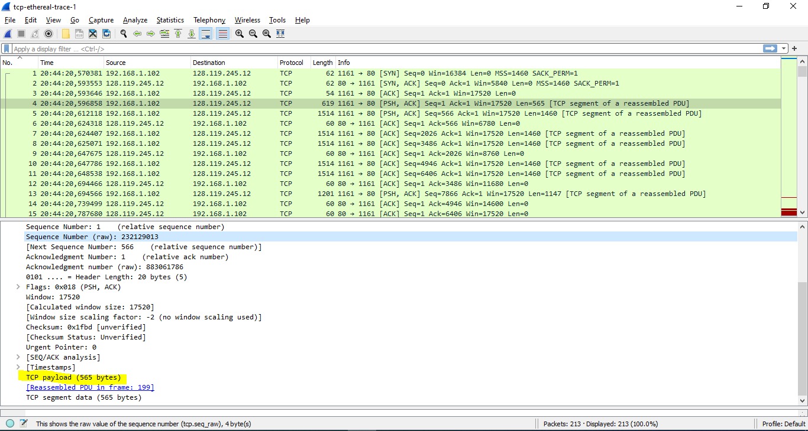

The length of the remaining TCP segments is 1460 bytes.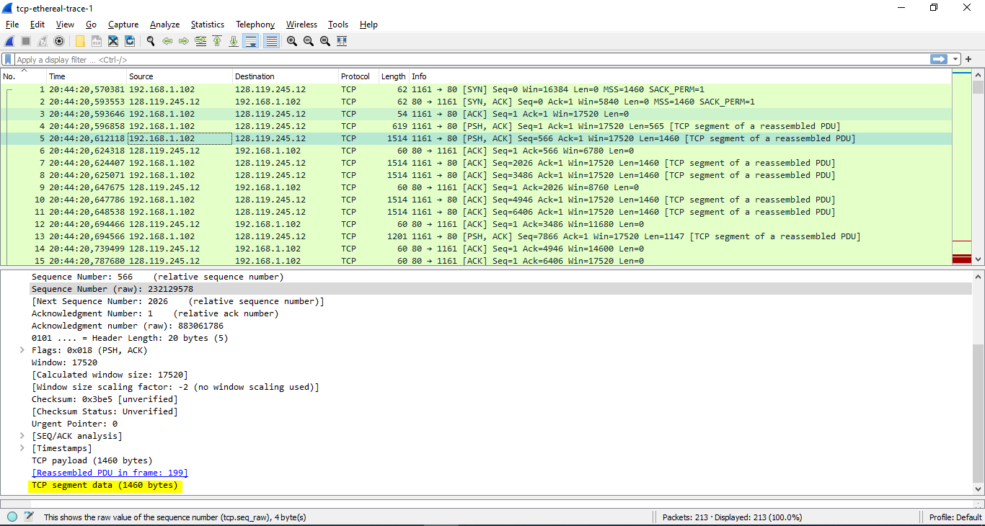

**Question 9:** What is the minimum amount of available buffer space advertised at the received for the entire trace? Does the lack of receiver buffer space ever throttle the sender?

**ANSWER:**

The minimum amount of available buffer space advertised at the received is 17520 bytes.

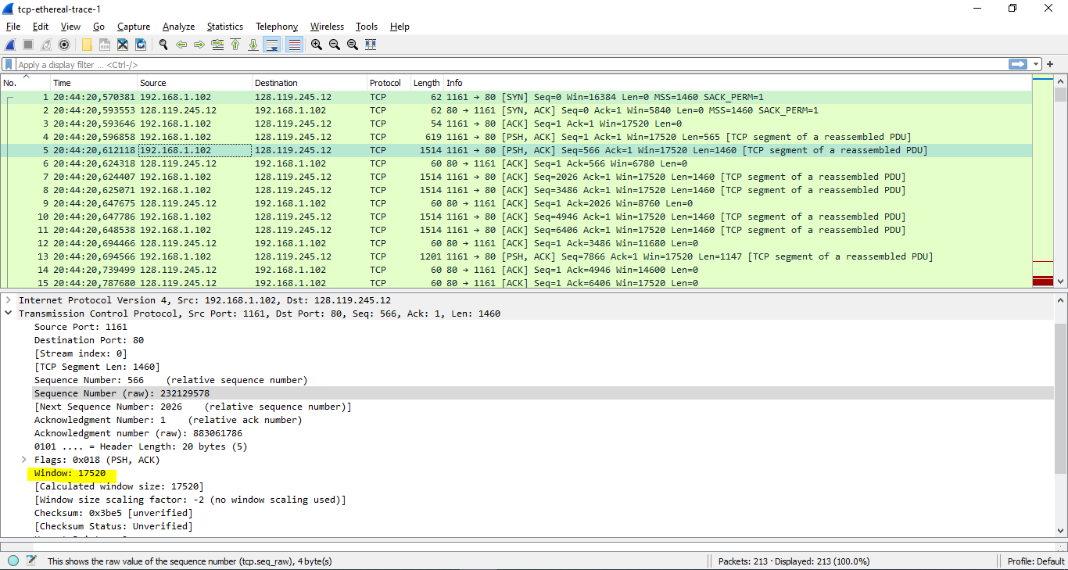

**Question 10**: Are there any retransmitted segments in the trace file? What did you check for (in the trace) in order to answer this question?

**ANSWER:**

No there is no retransmitted segments in the trace file.

**Question 11:** How much data does the receiver typically acknowledge in an ACK? Can youidentify cases where the receiver is ACKing every other received segment (see Table 3.2 on page 250 in the text).

**ANSWER:**

*ACK data = ACK sequence number - ACK sequence number

|  |  |  |
| --- | --- | --- |
|  | **ACK sequence number** | **ACK data** |
| **ACK1** | 2026 | 2026 |
| **ACK2** | 3486 | 1460 |
| **ACK3** | 4946 | 1460 |
| **ACK4** | 6406 | 1460 |
| **ACK5** | 7866 | 1460 |
| **AC6** | 9013 | 1147 |
| **…** |  |  |

**Question 12:** What is the throughput (bytes transferred per unit time) for the TCP connection? Explain how you calculated this value.

**ANSWER:**

Through-put = $\frac{Amount of data transmitted}{time incurred}$ = $\frac{181283}{26.221522-20.596858}=32230 bytes/s$

**4. TCP congestion control in action**

**Question 13**: Use the *Time-Sequence-Graph(Stevens*) plotting tool to view the sequence  
number versus time plot of segments being sent from the client to the  
gaia.cs.umass.edu server. Can you identify where TCP’s slowstart phase begins  
and ends, and where congestion avoidance takes over? Comment on ways in  
which the measured data differs from the idealized behavior of TCP that we’ve  
studied in the text

**ANSWER:**

Where congestion avoidance takes over: 0.04s

* Continuous + evenly distributed until the end

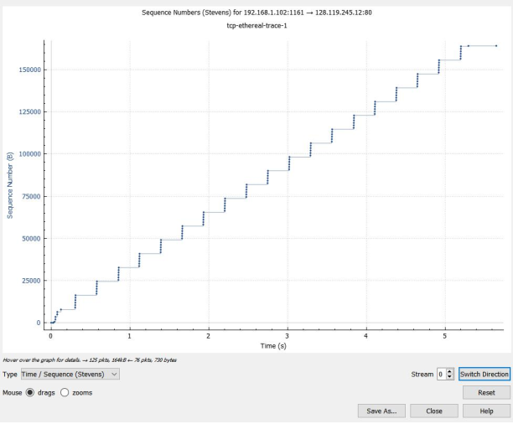

**Question 14:** Answer each of two questions above for the trace that you have gathered when  
you transferred a file from your computer to gaia.cs.umass.edu

**ANSWER:**

Done